Stage One - Design Specification

Agree on the purpose of the website
The main purpose of the website for the DinoLand theme park is to have a place where all information about the park can be found. This will facilitate in attracting new as well as engaging current customers. Old and new prospects of the theme park can view information about the park regarding pricing, hours of operation and the location of the park.

The website will show the different types of services offered such as what types of accommodations are available, dining options and also the different assortment of rides and shows they could expect to experience. Customers will also have the option to book tickets directly via the website. The purpose of this is to streamline the booking experience by allowing customers to book before they actually arrive at the park; this will facilitate less friction when entering the park.

The targeted demographic for the website are families. Families would look at this website to find the general information as stated above but also review photos of the park. Having photos of the different aspects of the park can help customers visualize the experience they could expect to have. Additionally important for the website regarding the family demographic, is to have maps showing the parts of the park which are suitable for different ages. For example, on a page which showcases the rides of the park, it becomes very important to include any age restrictions or limitations.

Research theme park websites
As a group we chose five theme park websites to review and compare different information, layouts and design aspects. The five websites include : DisneyWorld, Universal Orlando, Cedar Point, Knotts and Six Flags. After each person reviewed the websites we had a common discussion of the positive and negative aspects of each of the websites. The discussion concluded the following information below.

Disney World
Link - https://disneyworld.disney.go.com/
Positive aspects: | Negative aspects:
- Call to action at top of site allowing users to see availability | - Top nav bar is over-cluttered (too many items and not clear)
- Lots of images showing the park and people (helping visualize the experience) | - Video at top of website is distracting and slows down web page load time
- Mobile friendly

Universal Orlando
Link - https://www.universalorlando.com/web/en/us

Positive aspects: | Negative aspects:
- Displays clearly on homepage all of the different parks offered | - No clear call to action
- Many images for visualization | - Top nav bar looks like menu on mobile device and is also place on right side not left which is strange compared to most websites

Cedar Point
Link - https://www.cedarpoint.com/
Positive aspects: | Negative aspects:
- Easy to understand, no distracting videos at top | - Phone number isn’t above the fold and is hard to find
- Clear call to action

- Many images for visualization

Knotts
Link - https://www.knotts.com/
* Knotts has the same design as Cedar Point - potentially same company
Positive aspects: | Negative aspects:
- Easy to understand, no distracting videos at top | - Phone number isn’t above the fold and is hard to find
- Clear call to action

- Many images for visualization

Six Flags
Link - https://www.sixflags.com/greatadventure
Positive aspects: | Negative aspects:
- Call to action at top of site allowing users to see availability | - Phone number is hard to find
- Lots of images showing the park (helping visualize the experience) | - The Call To Action isn’t super clear
- Customers can book directly online | - Top Nav bar is too cluttered making it confusing for the user to know what to click
- Clear accommodation options and shows services offered

In general we concluded that it is important to have many images available to show people on the website the different types of people that go to the theme park, as well as maps showing which parts of the theme park are suitable for different ages. It is also very important to make clearly visible the contact details, booking options and the location of the park.

Agree on the content for the web site
The theme of our park is based on a dinosaur experience or relatable to Jurassic Park. Our park will have roller coasters, mechanical dinosaurs as well as shows and events with the general dinosaur theme. Including this will also be tropical birds since they come from dinosaurs and a few relatable reptiles such as crocodiles, alligators and turtles.

The types of visitors such as fans of the movies from Jurassic Park, families, individuals that enjoy wildlife and or animals, as well as general avid theme park goers will be pleased with the variety of dinosaur based rides and roller coasters available. The shows and events will also entice the visitors especially the younger children with the offered children dinosaur shows. The different shows, events and rides will cater to each demographic.

Based on discussions as a group we found that including accommodation options, maps of the park, available dining options, and easily found contact information is vital to include on the website. In general terms we believe we found what current and prospective customers will likely want to see, on such a website.

We agreed that all contact information such as address and telephone number should always be visible on the bottom of the pages and pricing should be clearly visible on the home page. In addition to this, it was concluded that the website should also have clear and visible calls to action, be that a “Book Now”-button, “Search”-button, or “Learn more”-buttons in clear highlight colors.

Agree on the structure of the web site

Website is three pages

1. Homepage
2. Places to stay
3. Rides & experiences

Each page has same top navigation bar with clear call to action and phone number visible

Each page will display the main relevant aspects of the theme park such as rides available, pricing etc
Jurassic Park Color Scheme & why we chose these colors:
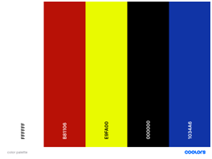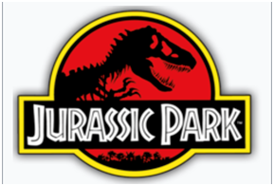

Background:
White: #ffffff

Highlight and intractable elements:
Red: #b81106 and some sharper red(#FF0000) highlights
Yellow: #e9fa00,

Text:
Black: #000000
Red: #b81106

Main theme
Blue #1034a6

Our color pallet:
We chose clear white background and black for text and dark red, this was for getting full contrast and maximum readability. For colors we have chosen Blue red and yellow in bright primary saturation. The bold primary colors are there to attract and keep the interest of our main group of visitors, families with children, with primary colors reminiscent of childhood. Blue is the dominant color with its broad bar at the top of the webpage. Red and yellow are used as highlights and to show interactivity. The images provide much of the color of the page. They also have a lot of blue, some white but we also get a bit of dark green from how dinosaurs and their vegetation are often presented. The pictures are also chosen to give a feeling of the actual nature of the place to inspire people to come also to see the spectacular nature in and around the park, and also there to inspire the smaller subset of people who want to visit the park for the nature and scenery.
Another focus group of the park are fans of the film “Jurassic Park”, and this is where we got our logo, and another reason for choosing red and yellow as highlight colors.

Choice of fonts and font-sizes:
We use the font “Fjalla one” with web safe Verdana and sans-serif as backup, for our blue bar and nav. Where we want both impact and readability. This text is big and should stand out, but remains very readable in this size. For the rest of the page we use the websafe Verdana with Tahoma and sans-serif as backup. Verdana is bold, strong and easy to read, even for the ones who just learned to read. We chose to capitalize the first letter instead of all bold for most text and the navigation elements. We saved all capitalized text for calls to actions and buttons.
Based on research and agreement from the group we agreed that the font size for the content of the website will be at a minimum of 16px. This was based on the factor that the content of the website should be naturally readable. Any viewer of the website, unless with special accessibility requirements, should be able to read the content, without making additional adjustments. The different headings of the WebPages are also larger than 16px in order to give emphasis and attract attention to certain areas of interest for the consumer.

Accessibility features:
We diligently used descriptive alt’s for media-files, so that those who have impaired sight can still get an understanding of the content. We have extensive media queries and layouts for different screen widths so the page can be used on various devices. We made the preview picture viewer in places_to_stay.html with pure css. This means that the page can be used even on systems that choose not to have javaScript enabled!

Structure of Css:
We have two general css files for site wide changes.In general.css we define general properties of the site as whole. Default fonts, borderboxing, 0 margin and default css for h2, and p. In header_footer_bar.css we have the code for the shared areas, the header/nav, footer and blue bar.
For the unique css for every page we have one css file for each page with the name style_NAME_OF_HTML.css, also the complex pure css picture carusel got its own css file, because of its size and to potentially make it easier to use it elsewhere in the site in the future.

NOTE: Search button on places_to_stay.html is functional – It changes between preview- and house listing-view!!

Design the wireframes for the website

Homepage desktop (George):

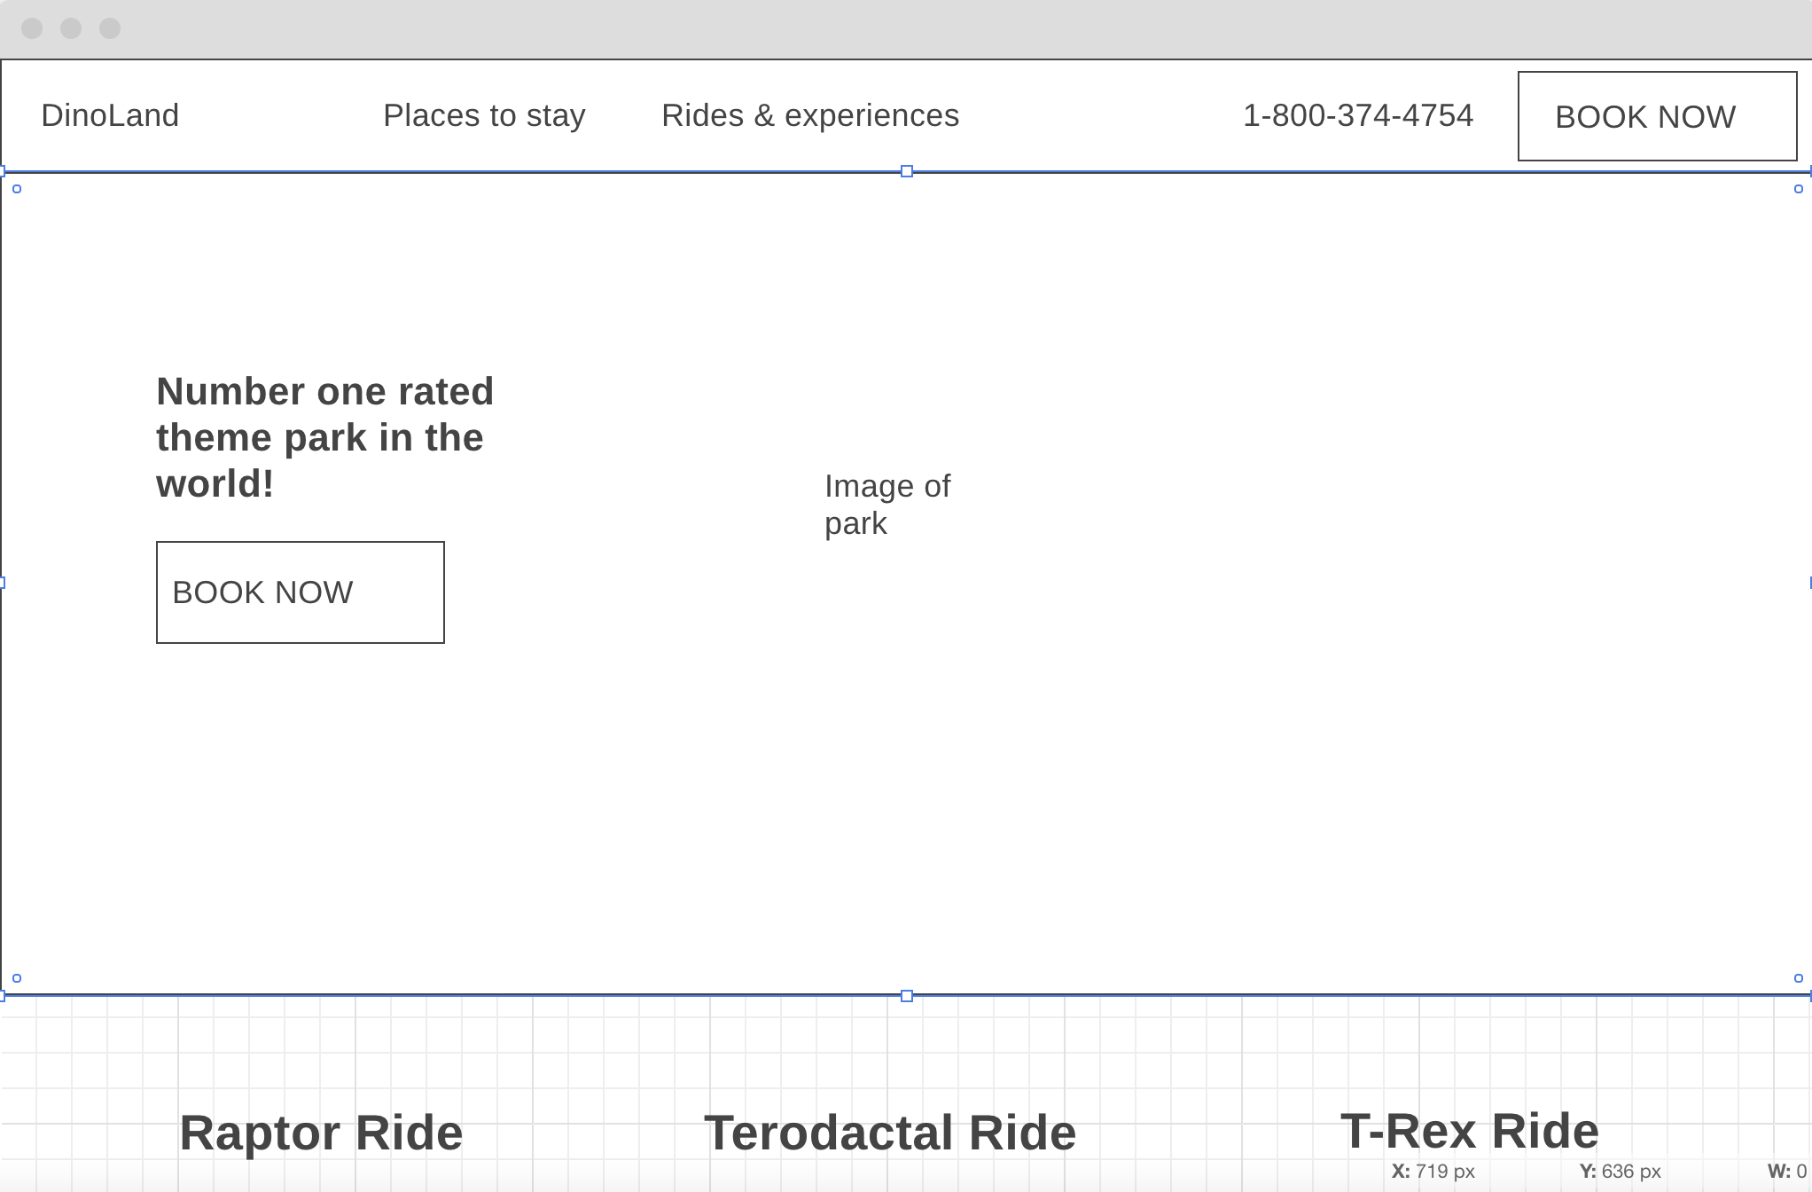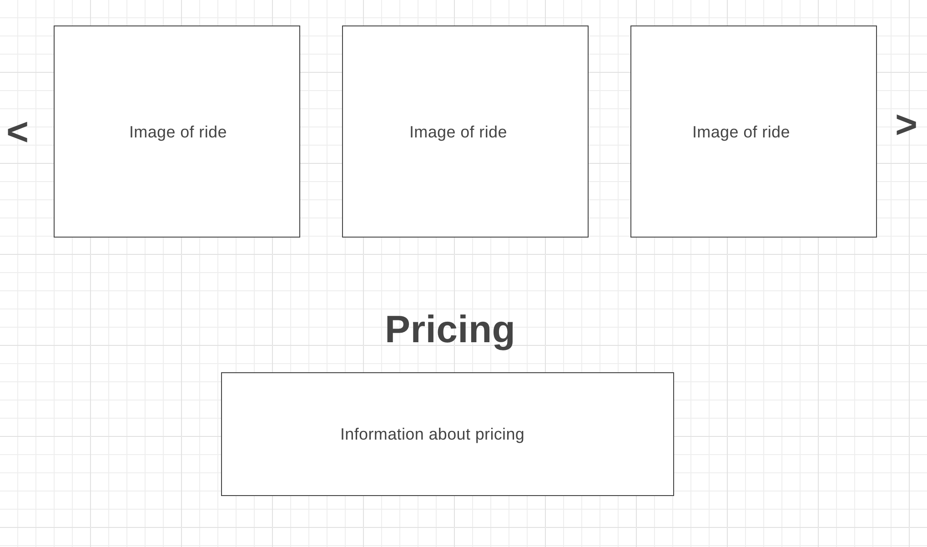
Homepage mobile (George):
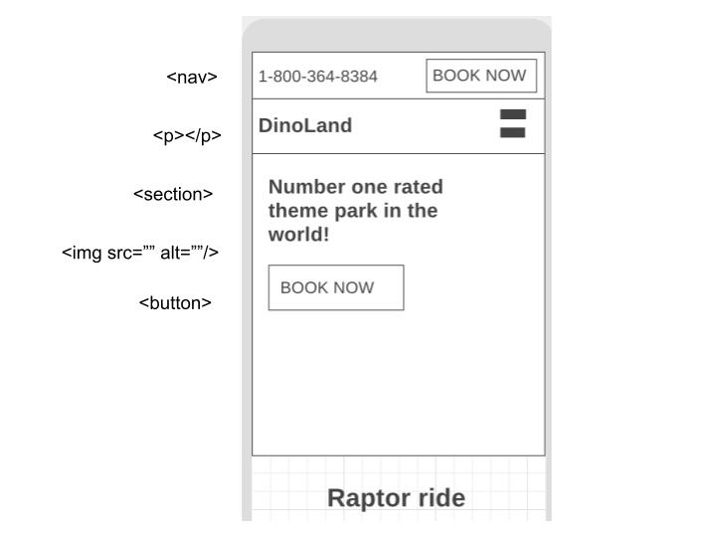
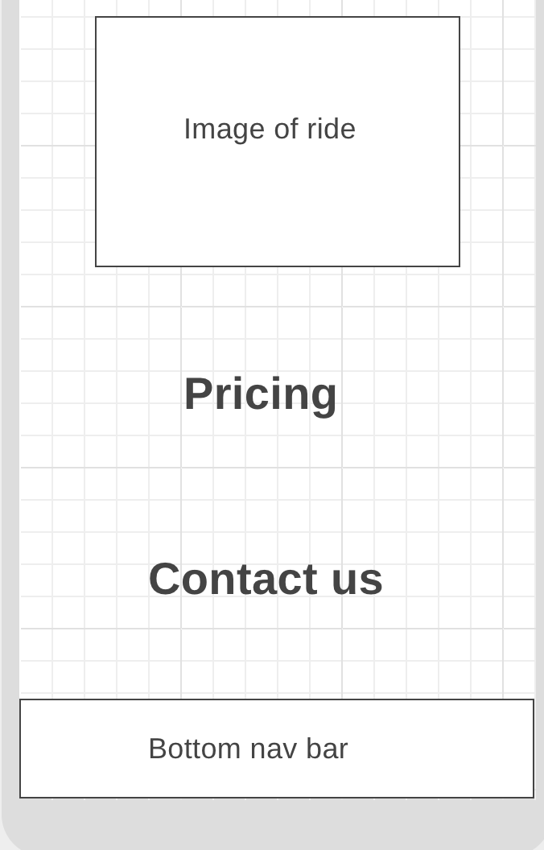
<nav><nav/>
<img src=”” alt=””/>
<div class=”main-flex-container”><div/>
<h2></h2>
<button></button>
<h2>
<nav id=”phone-and-button-top-nav”>
<img src=”” alt=””/>
<img src=”” alt=””/>
<img src=”” alt=””/>
<h2 class=”pricing”></h2>
<p></p>
<ul id=”price-ranges”></ul>
<img src=”” alt=”” />
<div>
<main>
<h2>
<h2>
<footer>

Places to stay Desktop with markup (Sveinbjørn):
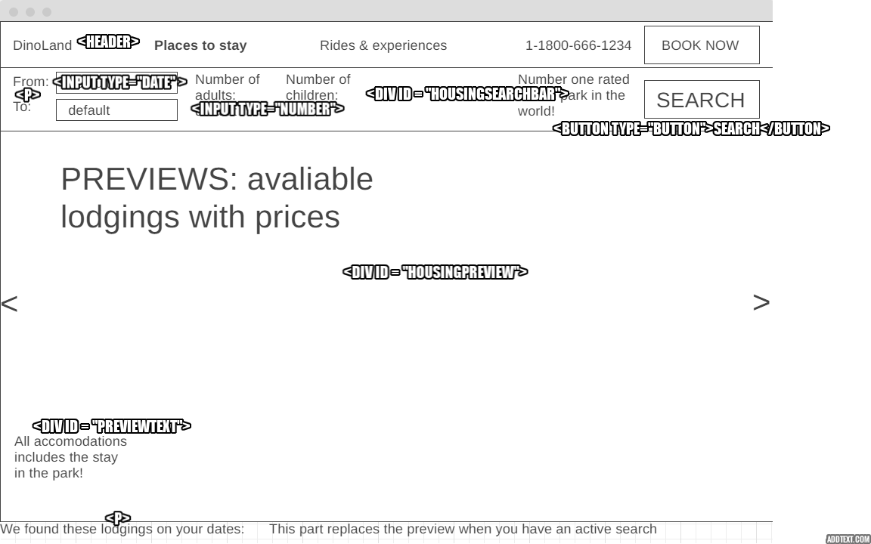
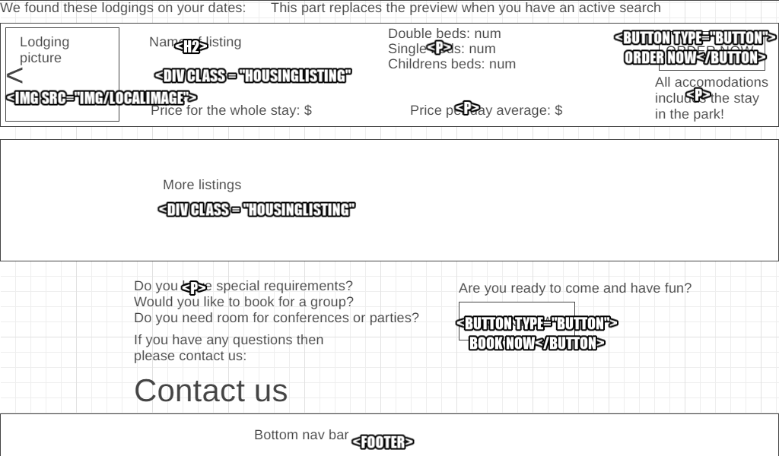
Places to stay mobile with markup (Sveinbjørn):
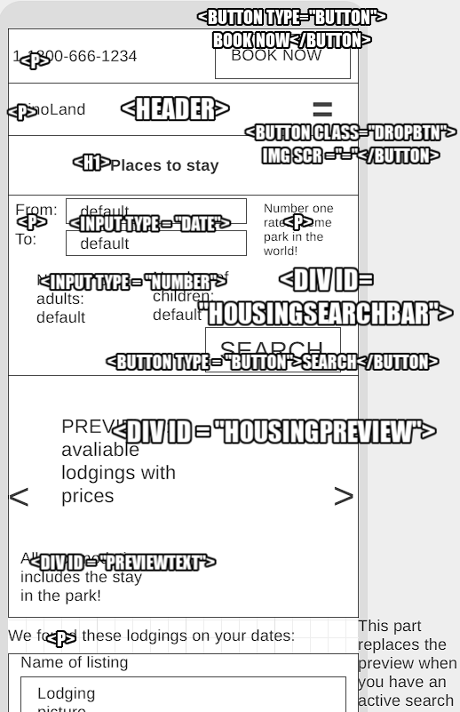
Places to stay Mobile cont.
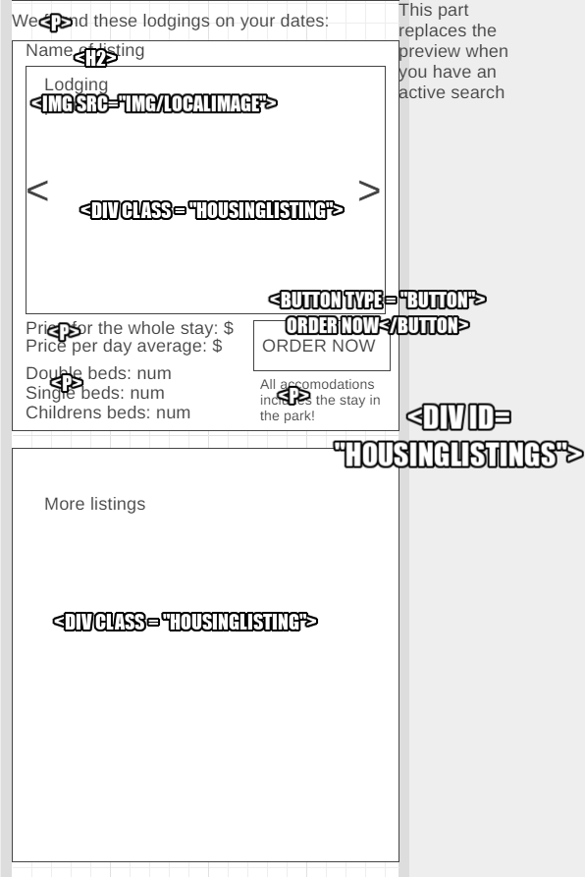

Places to stay Mobile cont.
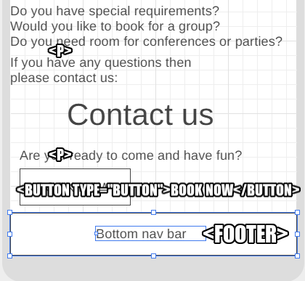

Rides and experiences Desktop(Martha) with Markup
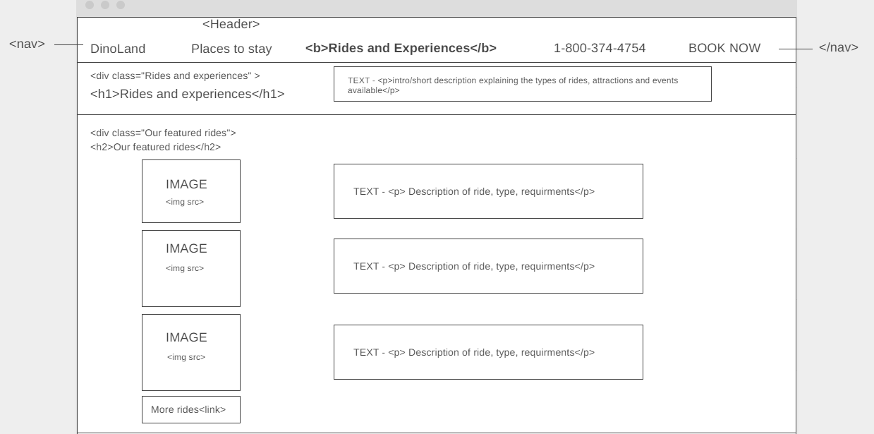
Rides and experiences Desktop cont.
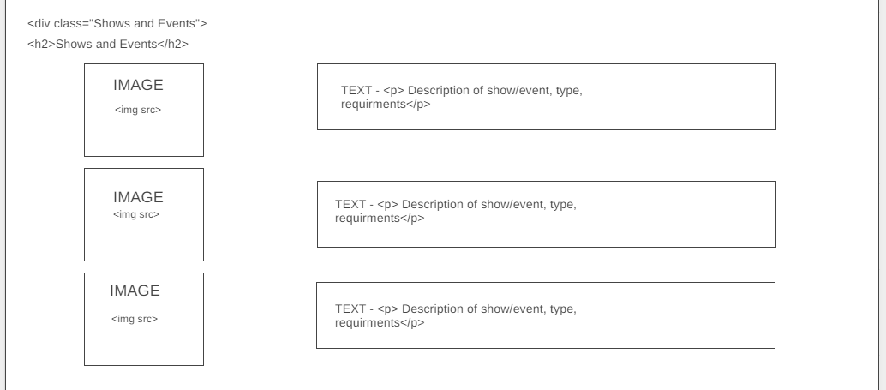

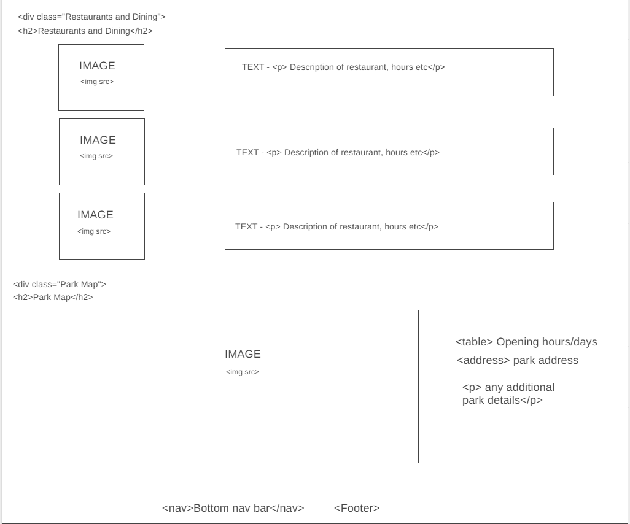

Rides and experiences mobile

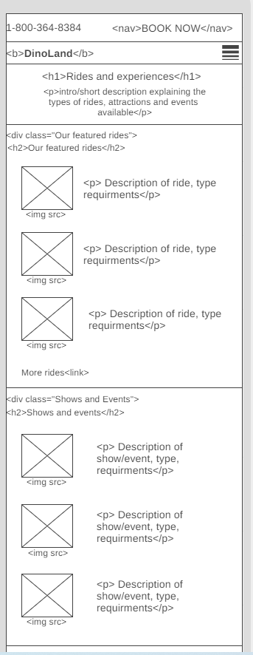

Rides and experiences Mobile cont.
